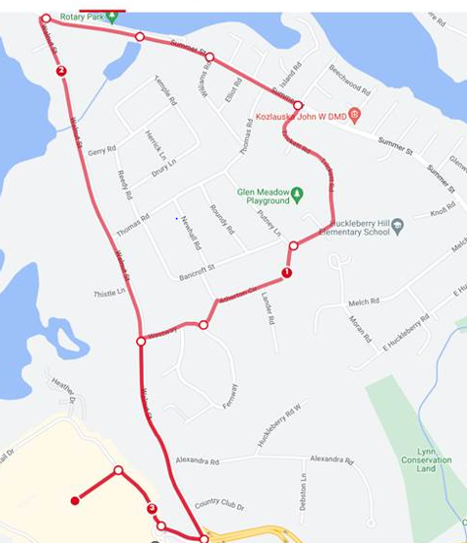
- Start at Davio’s
- Take a right on King Rail Dr
- At the traffic circle, take a left onto Market St
- Turn left onto Walnut St (police detail)
- Turn right onto Westway
- Turn right onto Atherton Cir
- Turn right onto Trickett
- Turn left onto Summer St
(Water stop is at 550 Summer St, Lynnfield)
- Turn left onto Walnut St (running along sidewalk)
- Turn right onto Market St
- At the traffic circle, take a right onto King Rail Dr
- Turn left toward Davio’s (start/finish line)



